**Assignment -1**

**Arduino Uno Programming**

|  |  |
| --- | --- |
| Assignment Date | 13 September 2022 |
| Student Name | 1. Sangeetha |
| Student Roll Number | 912419104026 |
| Maximum Marks | 2 Marks |

***To create circuit with Piezo alarm,PIR sensor,Temperature sensor with the following functionalities:***

***Question-1:***

***Alarm should sound in one manner if temperature is above 60 degree C:-***

***CODING FOR CIRCUIT***

***void setup()***

***{***

***Serial.begin(9600);***

***pinMode(5,OUTPUT);***

***}***

***void loop()***

***{***

***int data=analogRead(A0);***

***double n=data/1024;***

***double volt=n*6;***

***double off=volt-0.6;***

***double temperature=off*100;s***

***Serial.println(temperature);***

***tone(5,100);***

***delay(1000);***

***tone(5,200);***

***delay(1000);***

***}***

**SCREENSHOT:**

**CIRCUIT DIAGRAM**

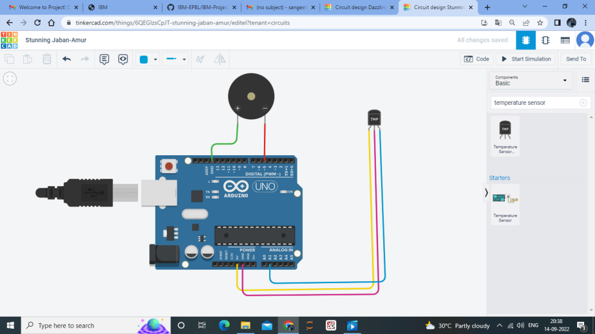

**CODING WITH CIRCUIT**

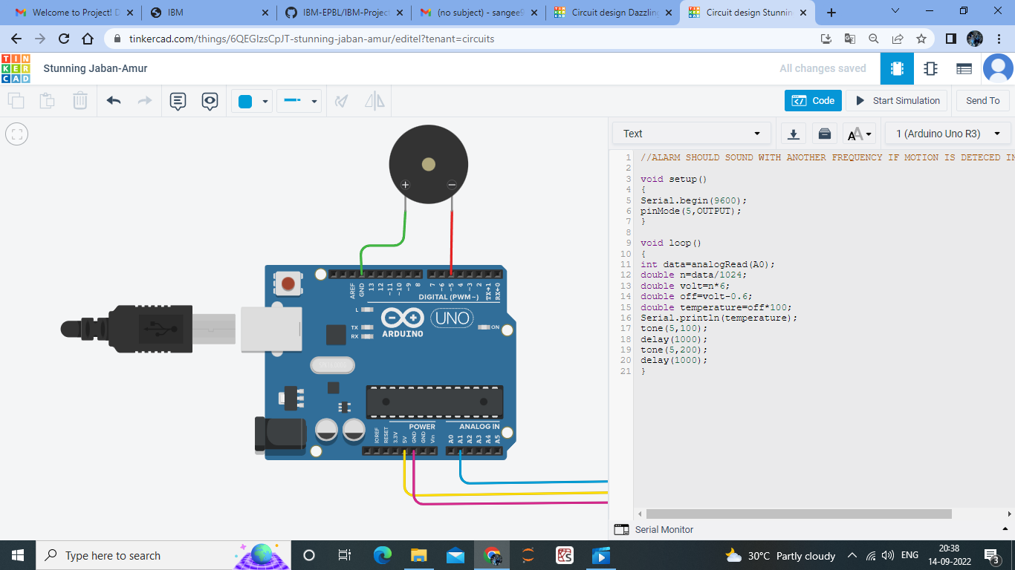

**Question-2**:

*Alarm should sound with another frequency if motion is detected in PIR sensor:-*

***CODING FOR CIRCUIT***

***void setup()***

***{***

***pinMode(2,INPUT);***

***pinMode(13,OUTPUT);***

***}***

***void loop()***

***{***

***if(digitalRead(2)==HIGH)***

***{***

***digitalWrite(13,HIGH);***

***}***

***else***

***{***

***digitalWrite(13,LOW);***

***}***

***delay(10); // Wait for 1000 millisecond(s)***

***}***

***SCREENSHOT:***

***CIRCUIT DIAGRAM***

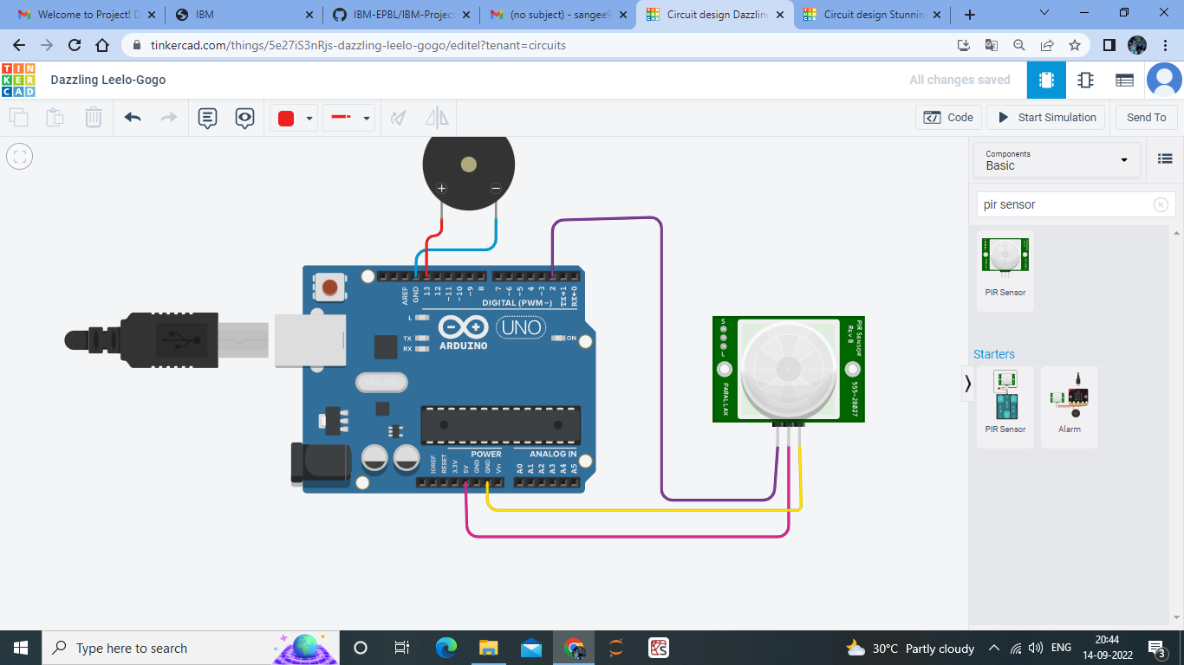

**CODING WITH CIRCUIT**

